In this assignment, you need to implement an Andrew’s Appliance Store calculator that looks like below using HTML, CSS and JavaScript:

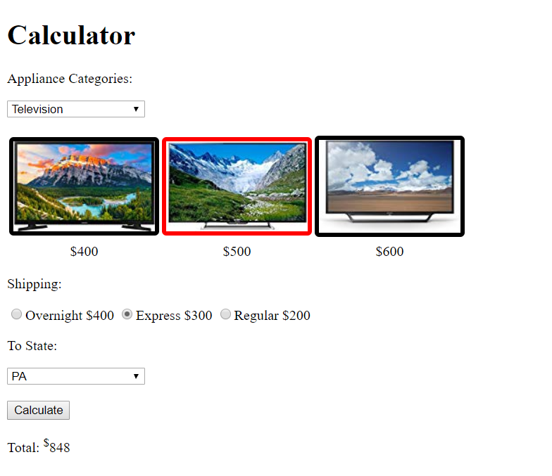

Files included in the project shell:

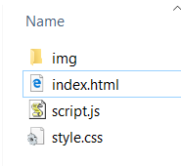



Requirements:

* When an Appliance Category is selected, load the 3 images corresponding to the category. Also display the appliance’s price according to the chart below:

|  |  |
| --- | --- |
| TV1 | 400 |
| TV2 | 500 |
| TV3 | 600 |
| Fridge1 | 700 |
| Fridge2 | 800 |
| Fridge3 | 900 |
| Washer1 | 1000 |
| Washer2 | 1100 |
| Washer3 | 1200 |

* When user click on the image, change the color of the border of the image to red. Also put the price of selected appliance to the “value” of the hidden “input” tag with id “selectedPrice”. At any time, only one selection (red border) is allowed.
* When user click “Calculate” button without selecting an appliance, prompt user to select one.
* When user click “Calculate” button without selecting a shipping option, prompt user to select one.
* When user click “Calculate” button without selecting a taxing state, prompt user to select one.
* When user click “Calculate” button and all required fields are entered, calculate the purchase total and display the result.